Yunus Güngör No:150150701 Date:17.04.2016

BLG202E CRN:21843 Homework 4

Q1)

>> syms x;

>> f(x)=exp(-x)\*sin(x);

>> integral=0;

>> h=(3-0)/10;

>> for k=1:10

integral=integral+(f(0+h\*(k-1))+f(0+(h\*k)));

end

>> integral=(h/2)\*integral

integral =

(3\*exp(-3)\*sin(3))/20 + (3\*exp(-3/2)\*sin(3/2))/10 + (3\*exp(-3/5)\*sin(3/5))/10 + (3\*exp(-6/5)\*sin(6/5))/10 + (3\*exp(-3/10)\*sin(3/10))/10 + (3\*exp(-9/5)\*sin(9/5))/10 + (3\*exp(-12/5)\*sin(12/5))/10 + (3\*exp(-9/10)\*sin(9/10))/10 + (3\*exp(-21/10)\*sin(21/10))/10 + (3\*exp(-27/10)\*sin(27/10))/10

>> vpa(integral)

ans =

0.5132326278134918587177495138721

>> int(f)

ans(x) =

-(exp(-x)\*(cos(x) + sin(x)))/2

>> ans(3)-ans(0)

ans =

1/2 - (exp(-3)\*(cos(3) + sin(3)))/2

>> vpa(ans)

ans =

0.52113143631128428503749688745287

>> abs(integral-ans)/ans %calculate error

ans =

0.0151570370686182

Q2)

>> syms x;

>> f(x)=x\*exp(2\*x);

>> h=(4-0)/4;

>> integral=0;

>> for k=1:1 %r/2=2 r/2-1=1

integral=integral+2\*f(0+(2\*k-2)\*h);

end

>> for k=1:2 %r/2=2

integral=integral+4\*(f(0+(2\*k-1)\*h));

end

>> integral=integral+f(0)+f(4);

>> integral=integral\*(h/3);

>> vpa(integral)

ans =

5598.17789815848

>> int(f)

ans(x) =

(exp(2\*x)\*(2\*x - 1))/4

>> ans(4)-ans(0)

ans =

(7\*exp(8))/4 + 1/4

>> vpa(ans)

ans =

5216.9264773230244808012861740426

>> (integral-ans)/ans %error

ans =

0.0730796997988542

Q3)

function [ result ] = compMid(m)

syms x;

f(x)=1+exp(-x)\*sin(8\*x^(2/3));

result=0;

h=(2-0)/m;

for i=1:m

result=result+f(0+(i-0.5)\*h);

end

result=result\*h;

end

>> m=[2, 4, 8, 16, 32, 60, 70, 100];

>> n=[compMid(2),compMid(4),compMid(8),compMid(16),compMid(32),compMid(60),compMid(70),compMid(100)];

>> vpa(n)

ans =

[ 1.2312160094741662892106778319419, 2.0111183723950209792049643091176, 2.051516783261768189892245899133, 2.0296063673806674447205729808381, 2.0206439591428174662552136906936, 2.0178298861476831083974206069886, 2.0174810171975077773770708666867, 2.0169450742923562242078367052761]

>> plot(m,n)

>>

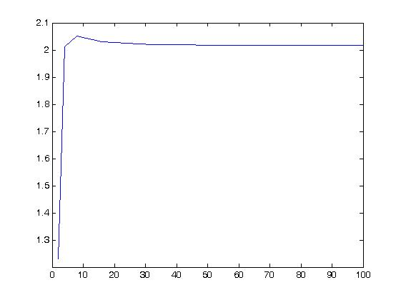

Q4)

>> a=0;

>> b=100;

>> h=0.01;

>> size=abs(a-b)/h;

>> y1(1)=80;

>> y2(1)=30;

>> for i=2:10001

k11=0.25\*y1(i-1)-0.01\*y1(i-1)\*y2(i-1);

k21=-1\*y2(i-1)+0.01\*y1(i-1)\*y2(i-1);

y1(i)=y1(i-1)+k11\*h;

y2(i)=y2(i-1)+k21\*h;

end

>> t=a:h:b;

>> figure

>> plot(t,y1,t,y2)

>>

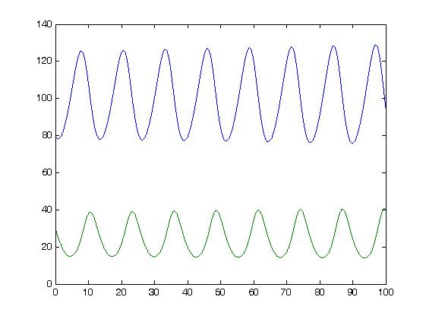

Q5)

>> a=0;

>> b=pi/2;

>> h=0.00005\*pi;

>> y(1)=80;

>> size=abs(a-b)/h;

>> for i=2:10001

t=(i-2)\*h;

k=1000\*(y(i-1)-cos(0+(i-1)\*h))-sin(t);

y(i)=y(i-1)-k\*h;

end

>> 1-y(10001) %error

ans =

0.998157081268119

>> h=0.0001\*pi;

>> for i=2:10001

t=(i-2)\*h;

k=1000\*(y(i-1)-cos(0+(i-1)\*h))-sin(t);

y(i)=y(i-1)-k\*h;

end

>> 1-y(10001) %error

ans =

1.99999842189198

>> h=0.0005\*pi;

>> for i=2:10001

t=(i-2)\*h;

k=1000\*(y(i-1)-cos(0+(i-1)\*h))-sin(t);

y(i)=y(i-1)-k\*h;

end

>> 1-y(10001) %error

ans =

1.99999912249383

>> h=0.001\*pi;

>> for i=2:10001

t=(i-2)\*h;

k=1000\*(y(i-1)-cos(0+(i-1)\*h))-sin(t);

y(i)=y(i-1)-k\*h;

end

>> h=0.001\*pi;

for i=2:10001

t=(i-2)\*h;

k=1000\*(y(i-1)-cos(0+(i-1)\*h))-sin(t);

y(i)=y(i-1)-k\*h;

end

>> 1-y(10001) %error

ans =

NaN

Small h makes calculations more accurute, also for h=0.001 method becomes unstable and result goes to infity.